Assignment -2

|  |  |
| --- | --- |
| Assignment Date | 17 September 2022 |
| Team ID | PNT2022TMID38850 |
| Project Name | EMERGING METHODS FOR EARLY DETECTION OF FOREST FIRES |
| Student Name | Jayanth.V |
| Student Roll Number | 421219104006 |
| Maximum Marks | 2 Marks |

# IMPORT LIBRARIES

import numpy as np import pandas as pd

import matplotlib.pyplot as pltimport seaborn as sns

# LOADING THE DATASET

df = pd.read_csv('Churn_Modelling.csv', encoding='latin-1')df

|  |  |  |  |  |  |  |  |  |
| --- | --- | --- | --- | --- | --- | --- | --- | --- |
| RowNumber CustomerId Surname | | | | | | CreditScore | Geography | Gender |
| Age | \ |  |  |  |  |  |  |  |
| 0 |  | 1 | 15634602 | | Hargrave | 619 | France | Female |
| 42 |  |  |  |  |  |  |  |  |
| 1 |  | 2 | 15647311 | | Hill | 608 | Spain | Female |
| 41 |  |  |  |  |  |  |  |  |
| 2 |  | 3 | 15619304 | | Onio | 502 | France | Female |
| 42 |  |  |  |  |  |  |  |  |
| 3 |  | 4 | 15701354 | | Boni | 699 | France | Female |
| 39 |  |  |  |  |  |  |  |  |
| 4 |  | 5 | 15737888 | | Mitchell | 850 | Spain | Female |
| 43  ... | ... |  | ... |  | ... | ... | ... | ... |
| ... 9995 | 9996 |  | 15606229 | | Obijiaku | 771 | France | Male |
| 39 |  |  |  |  |  |  |  |  |
| 9996 | 9997 |  | 15569892 | | Johnstone | 516 | France | Male |
| 35 |  |  |  |  |  |  |  |  |
| 9997 | 9998 |  | 15584532 | | Liu | 709 | France | Female |
| 36 |  |  |  |  |  |  |  |  |
| 9998 | 9999 |  | 15682355 | | Sabbatini | 772 | Germany | Male |
| 42 |  |  |  |  |  |  |  |  |
| 9999 | 10000 |  | 15628319 | | Walker | 792 | France | Female |
| 28 |  |  |  |  |  |  |  |  |
|  | Tenure | Balance | | NumOfProducts | | HasCrCard | IsActiveMember | \ |
| 0 | 2 |  | 0.00 |  | 1 | 1 |  | 1 |
| 1 | 1 | 83807.86 | |  | 1 | 0 |  | 1 |
| 2 | 8 | 159660.80 | |  | 3 | 1 |  | 0 |
| 3 | 1 |  | 0.00 |  | 2 | 0 |  | 0 |
| 4 | 2 | 125510.82 | |  | 1 1 | |  | 1 |
| ... | ... |  | ... |  | ... ... | |  | ... |
| 9995 | 5 |  | 0.00 |  | 2 1 | |  | 0 |
| 9996 | 10 | 57369.61 | |  | 1 1 | |  | 1 |

|  |  |  |  |  |  |
| --- | --- | --- | --- | --- | --- |
| 9997 | 7 | 0.00 | 1 | 0 | 1 |
| 9998 | 3 | 75075.31 | 2 | 1 | 0 |
| 9999 | 4 | 130142.79 | 1 | 1 | 0 |

|  |  |  |
| --- | --- | --- |
|  | EstimatedSalary | Exited |
| 0 | 101348.88 | 1 |
| 1 | 112542.58 | 0 |
| 2 | 113931.57 | 1 |
| 3 | 93826.63 | 0 |
| 4 | 79084.10 | 0 |
| ... | ... | ... |
| 9995 | 96270.64 | 0 |
| 9996 | 101699.77 | 0 |
| 9997 | 42085.58 | 1 |
| 9998 | 92888.52 | 1 |
| 9999 | 38190.78 | 0 |

[10000 rows x 14 columns]

# VISUALIZATIONS

*#visualization of categorical features*

fig, ax = plt.subplots(3, 2, figsize = (15, 12))plt.title("Visualization") sns.countplot('Geography', hue = 'Exited', data = df, ax = ax[0][0],palette='spring') sns.countplot('Gender', hue = 'Exited', data = df, ax = ax[0][1],palette='spring') sns.countplot('Tenure', hue = 'Exited', data = df, ax = ax[1][0],palette='spring') sns.countplot('NumOfProducts', hue = 'Exited', data = df, ax = ax[1][1],palette='spring') sns.countplot('HasCrCard', hue = 'Exited', data = df, ax = ax[2][0],palette='spring') sns.countplot('IsActiveMember', hue = 'Exited', data = df, ax = ax[2][1],palette='spring')

ax[0][0].set_title('Count Plot of Geography',color='red',fontsize=15)ax[0][1].set_title('Count Plot of Gender',color='red',fontsize=15) ax[1][0].set_title('Count Plot of Tenure',color='red',fontsize=15) ax[1][1].set_title('Count Plot of NumOfProducts',color='red',fontsize=15)

ax[2][0].set_title('Count Plot of HasCrCard',color='red',fontsize=15)ax[2][1].set_title('Count Plot of IsActiveMember',color='red',fontsize=15)

plt.tight_layout()plt.show()

/usr/local/lib/python3.7/dist-packages/seaborn/_decorators.py:43: FutureWarning: Pass the following variable as a keyword arg: x. From version 0.12, the only valid positional argument will be `data`, and passing other arguments without an explicit keyword will result in anerror or misinterpretation.

FutureWarning

/usr/local/lib/python3.7/dist-packages/seaborn/_decorators.py:43: FutureWarning: Pass the following variable as a keyword arg: x. From version 0.12, the only valid positional argument will be `data`, and passing other arguments without an explicit keyword will result in anerror or misinterpretation.

FutureWarning

/usr/local/lib/python3.7/dist-packages/seaborn/_decorators.py:43: FutureWarning: Pass the following variable as a keyword arg: x. From version 0.12, the only valid positional argument will be `data`, and passing other arguments without an explicit keyword will result in anerror or misinterpretation.

FutureWarning

/usr/local/lib/python3.7/dist-packages/seaborn/_decorators.py:43: FutureWarning: Pass the following variable as a keyword arg: x. From version 0.12, the only valid positional argument will be `data`, and passing other arguments without an explicit keyword will result in anerror or misinterpretation.

FutureWarning

/usr/local/lib/python3.7/dist-packages/seaborn/_decorators.py:43: FutureWarning: Pass the following variable as a keyword arg: x. From version 0.12, the only valid positional argument will be `data`, and passing other arguments without an explicit keyword will result in anerror or misinterpretation.

FutureWarning

/usr/local/lib/python3.7/dist-packages/seaborn/_decorators.py:43: FutureWarning: Pass the following variable as a keyword arg: x. From version 0.12, the only valid positional argument will be `data`, and passing other arguments without an explicit keyword will result in anerror or misinterpretation.

FutureWarning

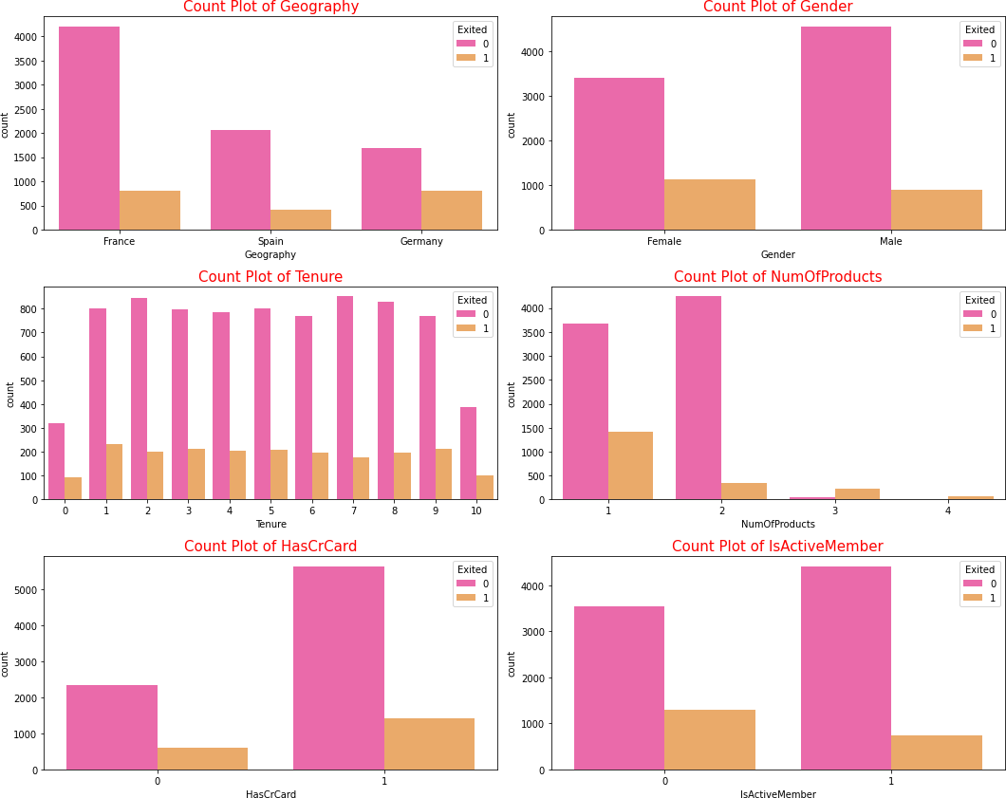

# DESCRIPTIVE STATISTICS

df.dtypes

RowNumber int64

CustomerId int64

Surname object

CreditScore int64

Geography object

Gender object

Age int64

Tenure int64

Balance float64

NumOfProducts int64

HasCrCard int64

IsActiveMember int64EstimatedSalary float64Exited int64 dtype: object

df_num = df[['RowNumber','Tenure','CustomerId','CreditScore','Age','NumOfProduc ts','HasCrCard','IsActiveMember','Exited']]

df_cat = df[['Surname','Geography','Gender']]df_num.head()

RowNumber Tenure CustomerId CreditScore Age NumOfProductsHasCrCard \

|  |  |  |  |  |  |  |
| --- | --- | --- | --- | --- | --- | --- |
| 0 | 1 | 2 | 15634602 | 619 | 42 | 1 |
| 1 |  |  |  |  |  |  |
| 1 | 2 | 1 | 15647311 | 608 | 41 | 1 |
| 0 |  |  |  |  |  |  |
| 2 | 3 | 8 | 15619304 | 502 | 42 | 3 |
| 1 |  |  |  |  |  |  |
| 3 | 4 | 1 | 15701354 | 699 | 39 | 2 |
| 0 |  |  |  |  |  |  |
| 4 | 5 | 2 | 15737888 | 850 | 43 | 1 |
| 1 |  |  | |  |  |  |
|  | IsActiveMember  1 | Exited | |  |  |  |
| 0 |  | 1 |  |  |  |
| 1 | 1 |  | 0 |  |  |  |
| 2 | 0 |  | 1 |  |  |  |
| 3 | 0 |  | 0 |  |  |  |
| 4 | 1 |  | 0 |  |  |  |

df_cat.head()

Surname Geography Gender

1. Hargrave France Female
2. Hill Spain Female
3. Onio France Female
4. Boni France Female
5. Mitchell Spain Female df_num.describe()

RowNumber Tenure CustomerId CreditScore

Age \

count 10000.00000 10000.000000 1.000000e+04 10000.000000

10000.000000

650.528800

|  |  |  |  |
| --- | --- | --- | --- |
| mean | 5000.50000 | 5.012800 | 1.569094e+07 |
| 38.921800  std | 2886.89568 | 2.892174 | 7.193619e+04 |
| 10.487806  min | 1.00000 | 0.000000 | 1.556570e+07 |
| 18.000000 |  |  |  |
| 25% | 2500.75000 | 3.000000 | 1.562853e+07 |
| 32.000000 |  |  |  |
| 50% | 5000.50000 | 5.000000 | 1.569074e+07 |
| 37.000000 |  |  |  |
| 75% | 7500.25000 | 7.000000 | 1.575323e+07 |
| 44.000000 |  |  |  |

96.653299

350.000000

584.000000

652.000000

718.000000

max 10000.00000 10.000000 1.581569e+07 850.000000

92.000000

|  |  |  |  |  |
| --- | --- | --- | --- | --- |
|  | NumOfProducts | HasCrCard | IsActiveMember | Exited |
| count | 10000.000000 | 10000.00000 | 10000.000000 | 10000.000000 |
| mean | 1.530200 | 0.70550 | 0.515100 | 0.203700 |
| std | 0.581654 | 0.45584 | 0.499797 | 0.402769 |
| min | 1.000000 | 0.00000 | 0.000000 | 0.000000 |
| 25% | 1.000000 | 0.00000 | 0.000000 | 0.000000 |
| 50% | 1.000000 | 1.00000 | 1.000000 | 0.000000 |
| 75% | 2.000000 | 1.00000 | 1.000000 | 0.000000 |
| max | 4.000000 | 1.00000 | 1.000000 | 1.000000 |

df_cat.describe(exclude = ['int64','float64'])Surname Geography Gender

|  |  |  |  |
| --- | --- | --- | --- |
| count | 10000 | 10000 | 10000 |
| unique | 2932 | 3 | 2 |
| top | Smith | France | Male |
| fHrAeNqDLE | THE M32ISS | ING V5A01L4U | S 5457 |

print("Column Missing values")print(" ") df.isnull().sum()

Column Missing values

RowNumber 0

CustomerId 0

Surname 0

CreditScore 0

Geography 0

Gender 0

Age 0

Tenure 0

Balance 0

NumOfProducts 0

HasCrCard 0

IsActiveMember 0

EstimatedSalary 0

Exited 0

dtype: int64

print(f"Our target variable is Exited. We can observe that it has onlytwo possible variables:

{df['Exited'].unique().tolist()}")

Our target variable is Exited. We can observe that it has only twopossible variables: [1, 0] df.drop(['RowNumber', 'CustomerId', 'Surname'], axis=1, inplace=True)

new_names = {

'CreditScore': 'credit_score','Geography':

'country', 'Gender': 'gender', 'Age': 'age',

'Tenure': 'tenure', 'Balance':

'balance',

'NumOfProducts': 'number_products', 'HasCrCard': 'owns_credit_card', 'IsActiveMember': 'is_active_member', 'EstimatedSalary': 'estimated_salary','Exited': 'exited'

}

df.rename(columns=new_names, inplace=True)df.head()

|  |  |  |  |  |  |  |
| --- | --- | --- | --- | --- | --- | --- |
| credit_score number_products | country  \ | | gender | age | tenure | balance |
| 0 | 619 | France | Female | 42 | 2 | 0.00 |
| 1 |  |  |  |  |  |  |
| 1 | 608 | Spain | Female | 41 | 1 | 83807.86 |
| 1 |  |  |  |  |  |  |
| 2 | 502 | France | Female | 42 | 8 | 159660.80 |
| 3 |  |  |  |  |  |  |
| 3 | 699 | France | Female | 39 | 1 | 0.00 |
| 2 |  |  |  |  |  |  |
| 4 | 850 | Spain | Female | 43 | 2 | 125510.82 |
| 1 |  |  |  |  |  |  |

owns_credit_card is_active_member estimated_salary exited0 1

|  |  |  |  |  |
| --- | --- | --- | --- | --- |
|  | 1 | 101348.88 | 1 |  |
| 1 | 0 | 1 | 112542.58 | 0 |
| 2 | 1 | 0 | 113931.57 | 1 |
| 3 | 0 | 0 | 93826.63 | 0 |
| 4 | 1 | 1 | 79084.10 | 0 |

# REPLACE OUTLIERS

**def** detect_outlier(df):

outlier = [] threshold =

3 mean = np.mean(df)std = np.std(df) **for** i **in** df:

z_score = (i - mean)/std

**if** np.abs(z_score)>threshold: outlier.append(i)

**return** outlier

CreditScore_list = df['CreditScore'].tolist()Balance_list = df['Balance'].tolist()

EstimatedSalary_list = df_cat['EstimatedSalary'].tolist()CreditScore_outlier = detect_outlier(CreditScore_list) CreditScore_outlier

Output-[359, 350, 350, 358, 351, 350, 350, 350]

Balance_outlier = detect_outlier(Balance_list)Balance_outlier EstimatedSalary_outlier = detect_outlier(EstimatedSalary_list)

EstimatedSalary_outlier

print("Shape of Data before removing outliers: {}".format(df.shape))Shape of Data before removing outliers: (10000, 11)

# ENCODING

*# Encoding Categorical variables into numerical variables# One Hot Encoding*

x = pd.get_dummies(x)x.head() x.shape

(10000, 13)

# SPLIT THE DATA INTO DEPENDENT AND INDEPENDENT VARIALBLES

*# splitting the dataset into x(independent variables) and y(dependentvariables)*

x = df.iloc[:,0:10]

y = df.iloc[:,10]

print(x.shape) print(y.shape)

print(x.columns)

*#print(y)*

(10000, 10)

(10000,)

Index(['credit_score', 'country', 'gender', 'age', 'tenure','balance',

'number_products', 'owns_credit_card', 'is_active_member','estimated_salary'], dtype='object')

# SCALE THE INDEPENDENT VARIABLES

from sklearn.preprocessing import StandardScalersc = StandardScaler()

x_train = pd.DataFrame(x_train) x_train.head()

credit_score country gender age tenure balance number_products \

|  |  |  |  |  |  |  |
| --- | --- | --- | --- | --- | --- | --- |
| 2967 | 579 | Germany | Female | 39 | 5 | 117833.30 |
| 3 |  |  |  |  |  |  |
| 700 | 750 | France | Female | 32 | 5 | 0.00 |
| 2 |  |  |  |  |  |  |
| 3481 | 729 | Spain | Female | 34 | 9 | 53299.96 |
| 2 |  |  |  |  |  |  |
| 1621 | 689 | Spain | Male | 38 | 5 | 75075.14 |
| 1 |  |  |  |  |  |  |
| 800 | 605 | France | Male | 52 | 7 | 0.00 |
| 2 |  |  |  |  |  |  |
| owns_credit_card | | is_active_member | | estimated_salary | | |
| 2967 |  | 0 |  | 0 |  | 5831.00 |
| 700 |  | 1 |  | 0 |  | 95611.47 |
| 3481 |  | 1 |  | 1 |  | 42855.97 |
| 1621 |  | 1 |  | 1 |  | 8651.92 |
| 800 |  | 1 |  | 1 | 173952.50 | |

# SPLIT THE DATA INTO TRAINING AND TESTING

*# splitting the data into training and testing set*

from sklearn.model_selection import train_test_split

x_train, x_test, y_train, y_test = train_test_split(x, y, test_size =0.25, random_state = 0)

print(x_train.shape) print(y_train.shape) print(x_test.shape) print(y_test.shape)

(7500, 10)

(7500,)

(2500, 10)

(2500,)